Functions

Accessing Functions
- Get the list of recently used functions:
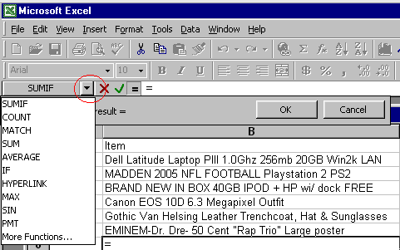
- Get the full list of functions:
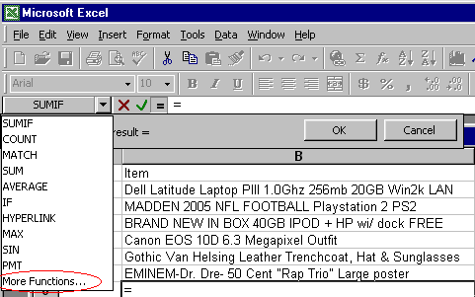

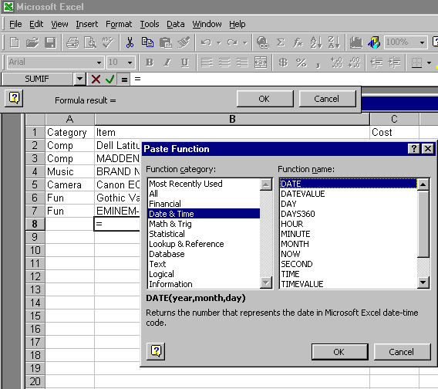

Functions of interest:
MAX(number1,number2,...)
Number1,number2,... are 1 to 30 numbers for which you want to find the maximum value.
- You can specify arguments that are numbers, empty cells, logical values, or text representations of numbers. Arguments that are error values or text that cannot be translated into numbers cause errors.
- If an argument is an array or reference, only numbers in that array or reference are used. Empty cells, logical values, or text in the array or reference are ignored.
- If the arguments contain no numbers, MAX returns 0 (zero).
AVERAGE(number1,number2, ...)
Number1, number2, ... are 1 to 30 numeric arguments for which you want the average.
Remarks
- The arguments must be either numbers or names, arrays, or references that contain numbers.
- If an array or reference argument contains text, logical values, or empty cells, those values are ignored; however, cells with the value zero are included.

- Empty cells are not counted, but zero values are.

MIN(number1,number2, ...)
Number1, number2,... are 1 to 30 numbers for which you want to find the minimum value.
- You can specify arguments that are numbers, empty cells, logical values, or text representations of numbers. Arguments that are error values or text that cannot be translated into numbers cause errors.
- If an argument is an array or reference, only numbers in that array or reference are used. Empty cells, logical values, or text in the array or reference are ignored.
- If the arguments contain no numbers, MIN returns 0.
SUM(number1,number2, ...)
Number1, number2, ... are 1 to 30 arguments for which you want the total value or sum.
- Numbers, logical values, and text representations of numbers that you type directly into the list of arguments are counted. See the first and second examples following.
- If an argument is an array or reference, only numbers in that array or reference are counted. Empty cells, logical values, text, or error values in the array or reference are ignored. See the third example following.
- Arguments that are error values or text that cannot be translated into numbers cause errors.
SUMIF(range,criteria,sum_range)
Range is the range of cells you want evaluated.
Criteria is the criteria in the form of a number, expression, or text that defines which cells will be added. For example, criteria can be expressed as 32, "32", ">32", "apples".
Sum_range are the actual cells to sum. The cells in sum_range are summed only if their corresponding cells in range match the criteria. If sum_range is omitted, the cells in range are summed.
Example
Suppose A1:A4 contain the following property values for four homes: $100,000, $200,000, $300,000, $400,000, respectively. B1:B4 contain the following sales commissions on each of the corresponding property values: $7,000, $14,000, $21,000, $28,000.
SUMIF(A1:A4,">160000",B1:B4) equals $63,000

